大一理论考试：<https://exam.kaoshixing.com/exam/enter_exam/5488/265338>

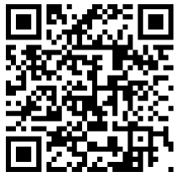

大二专项考试：

篮球专项：<https://exam.kaoshixing.com/exam/enter_exam/5488/265398>

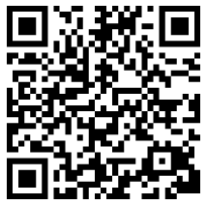

足球专项：<https://exam.kaoshixing.com/exam/enter_exam/5488/265399>

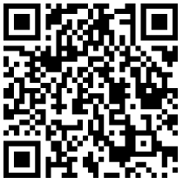

乒乓球专项：<https://exam.kaoshixing.com/exam/enter_exam/5488/265405>

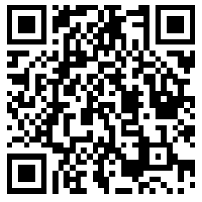

羽毛球专项：<https://exam.kaoshixing.com/exam/enter_exam/5488/265418>

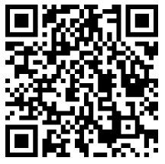

网球专项：<https://exam.kaoshixing.com/exam/enter_exam/5488/265428>

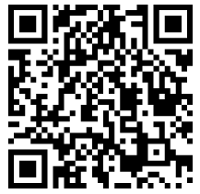

体育舞蹈专项：<https://exam.kaoshixing.com/exam/enter_exam/5488/265430>

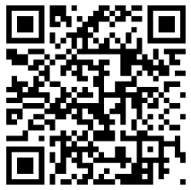

散打专项：<https://exam.kaoshixing.com/exam/enter_exam/5488/265432>

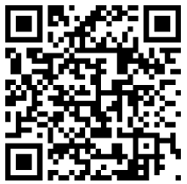

骑行专项：<https://exam.kaoshixing.com/exam/enter_exam/5488/265436>

