（1）登录考试流程，填写账号密码。（左侧是电脑端，右侧是手机端）

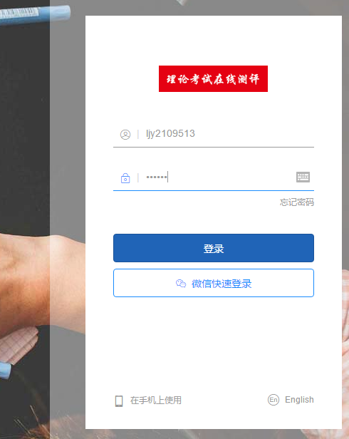 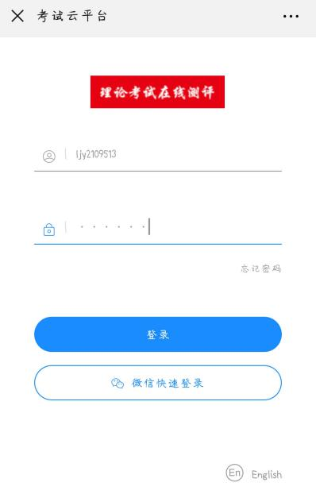

（2）点击开始考试

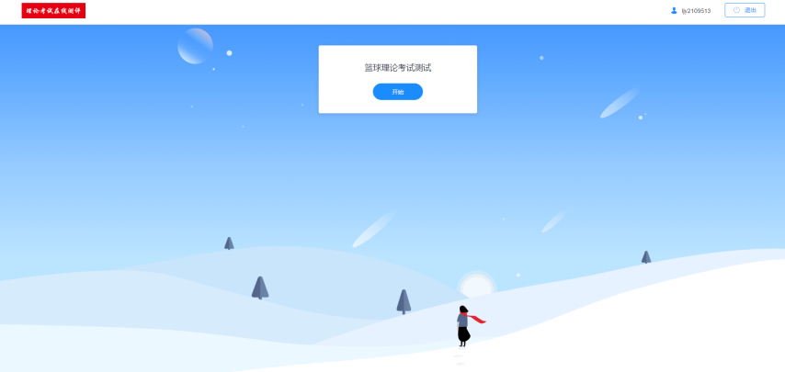 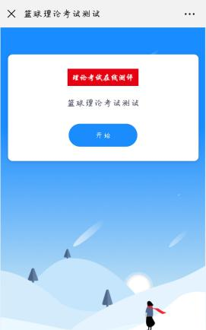

（3）可以从答题卡里面查看已做题目和未做题目，点击题目序号可以直接到当前题目。

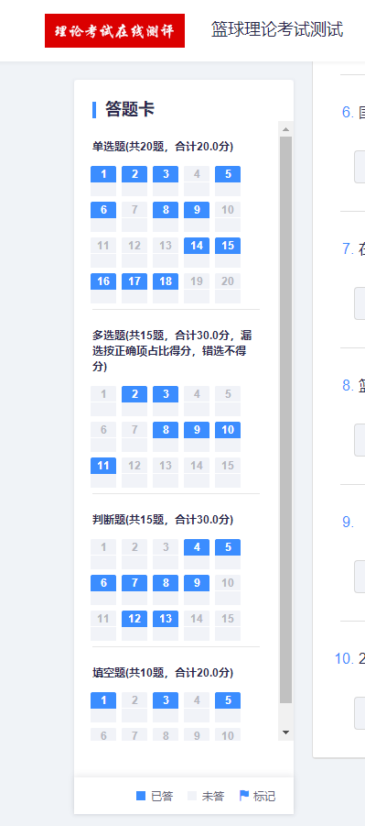 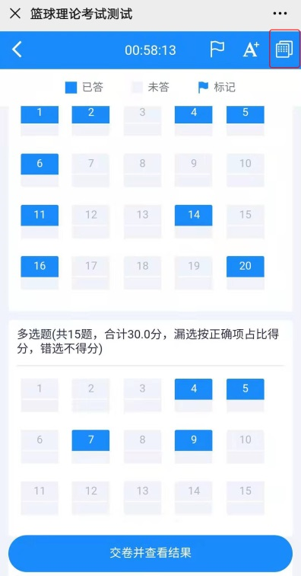

（4）答完试题之后点击提交试卷。

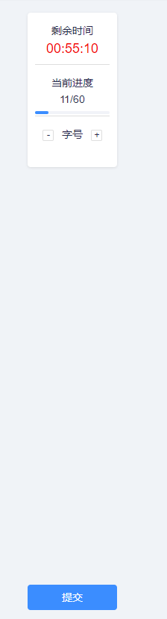 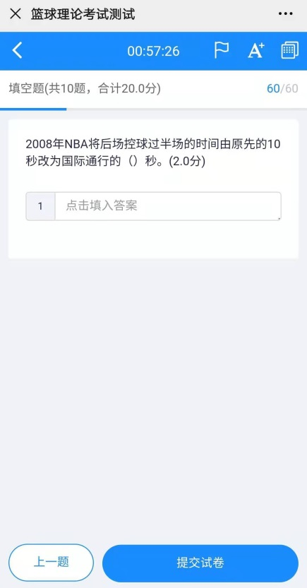

大一理论考试：<https://exam.kaoshixing.com/exam/enter_exam/5488/638013>



大二专项考试：

篮球专项：<https://exam.kaoshixing.com/exam/enter_exam/5488/638017>



足球专项：<https://exam.kaoshixing.com/exam/enter_exam/5488/638075>



乒乓球专项：<https://exam.kaoshixing.com/exam/enter_exam/5488/638033>



羽毛球专项：<https://exam.kaoshixing.com/exam/enter_exam/5488/638059>



网球专项：<https://exam.kaoshixing.com/exam/enter_exam/5488/638042>



散打专项：<https://exam.kaoshixing.com/exam/enter_exam/5488/638064>



骑行专项：<https://exam.kaoshixing.com/exam/enter_exam/5488/638036>



拓展专项：<https://exam.kaoshixing.com/exam/enter_exam/5488/638049>

